**COMPUTER NETWORKS - CSA07**

**Parthibhan .R**

**192224275**

**EXPRIMENT 5:-**

Data Link Layer Traffic Simulation using Packet Tracer Analysis of ARP

Github Link :- <https://github.com/parthibhan007/CSA0748-computer-network/tree/main/expriment%205>

Simulation:-

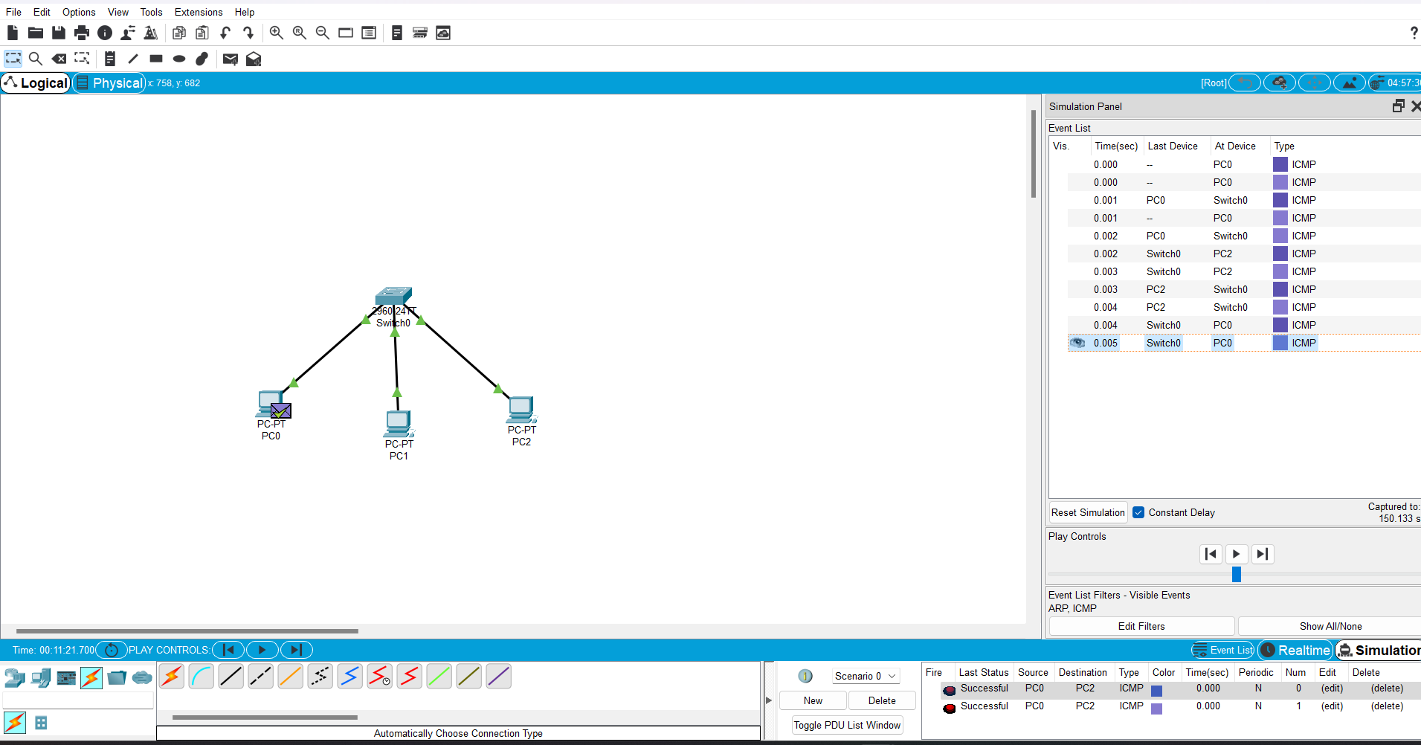

Real Time:-

